**Deploy Static Website on AWS**

1. **S3 Bucket:**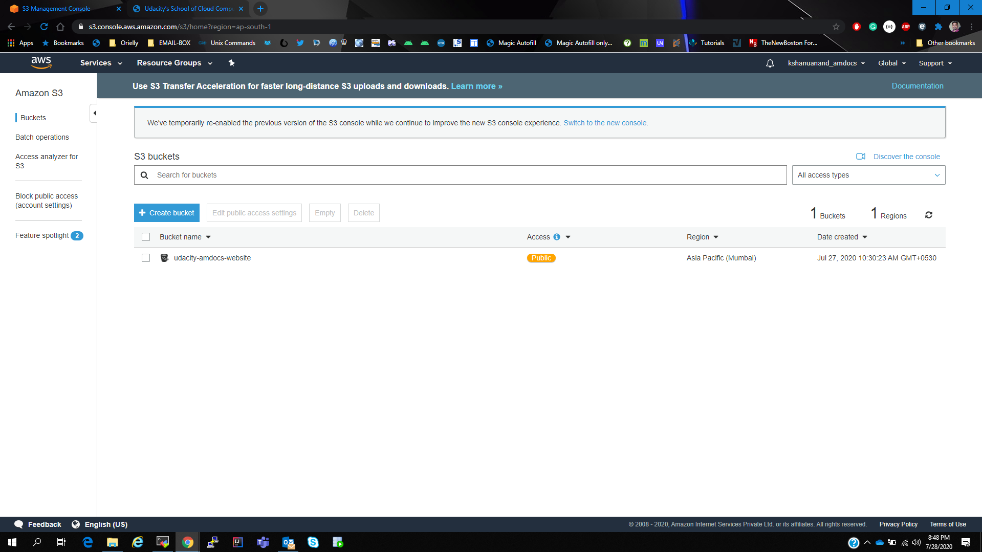
2. **Website Files in S3 Bucket:** 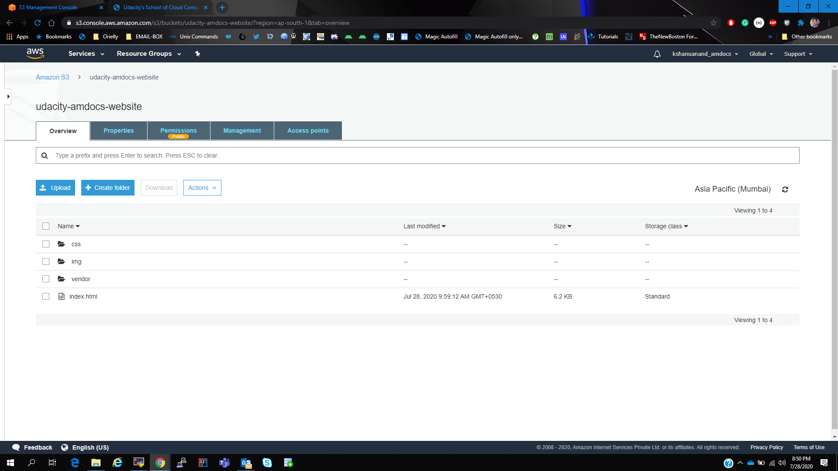
3. **Static web hosting configuration:** 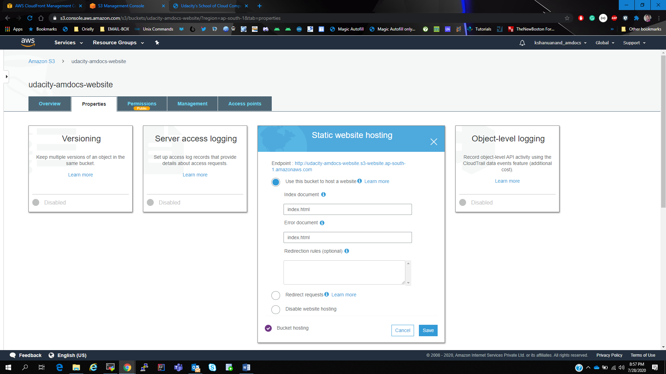
4. **IAM bucket policy to support public access:** 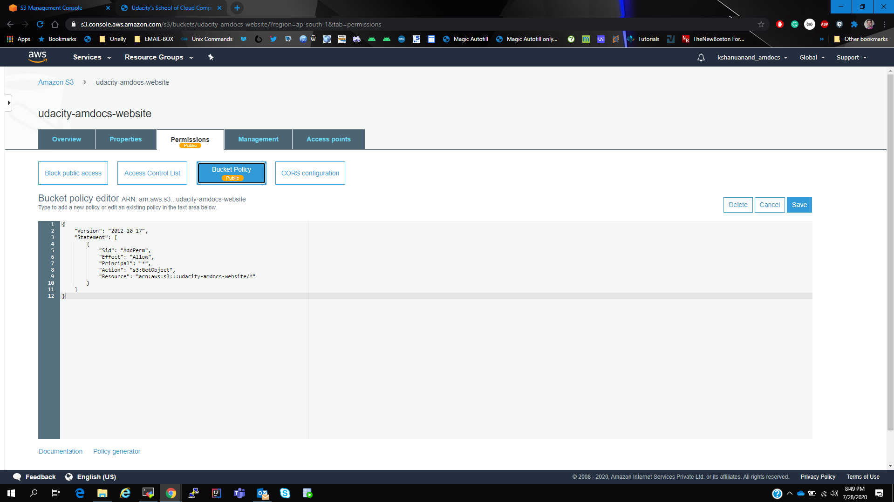
5. **Cloud Front name:** 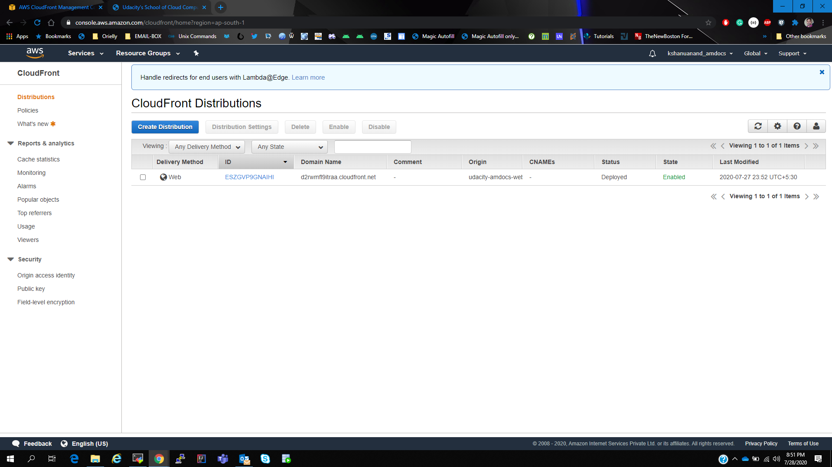
6. **Cloud front configuration pointing to S3 bucket:** 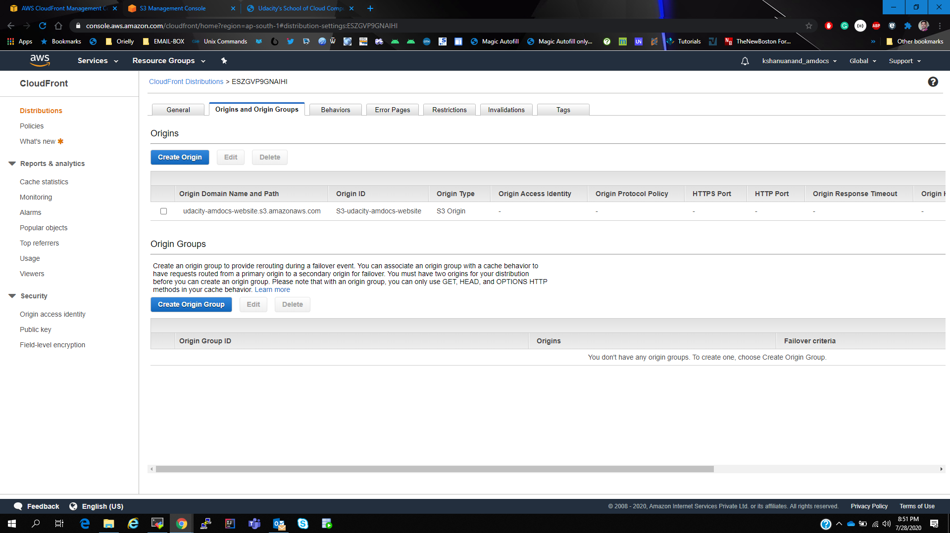
7. **Access website using cloud front url:** 